**Landing, Login, and Enrollment Pages Development**

Be Huynh

University of Arizona Global Campus

CST499: Capstone for Computer Software Technology

Professor Joseph Rangitsch

February 17, 2025

**Introduction**

Running PHP files in XAMPP is a simple way to build and test web applications on your computer. XAMPP includes Apache, MySQL, and PHP, making it easy to run PHP projects. In this guide, I'll show you how to set up PHP, create a registration page for new users, and save their information in a MySQL database. I will also explain how to create a custom class to manage the database connection.

**How to Run a PHP File in XAMPP**

To run a PHP file in XAMPP, the first step is to download and install XAMPP from its official website. Once installed, open the XAMPP Control Panel and start both the Apache and MySQL services. These services are necessary to run PHP and interact with the database. Next, create a PHP file using a text editor like Notepad++ or Visual Studio Code, and save it with a .php extension (e.g., index.php). After that, move the file to the htdocs folder in the XAMPP directory. To see your file in action, open a web browser and go to http://localhost/index.php.

**Create the landing page, login page, and registration page for new users.**



**Discuss the MySQL database functions that you used and the steps you took to create the database connection custom class.**

To connect PHP to a MySQL database, use the mysqli_connect() function. This function requires the database server (usually localhost), the username (often root), the password, and the database name. The connection is stored in a variable like $conn, which you can later use to perform database operations. If the connection fails, an error message will be shown. You can also create a custom class to handle database connections, making your code more organized and reusable. This class can include methods to open the connection, close it, and run queries, making it easier to maintain your code.

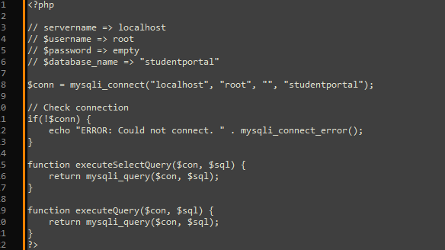

**Develop the registration page layout.**

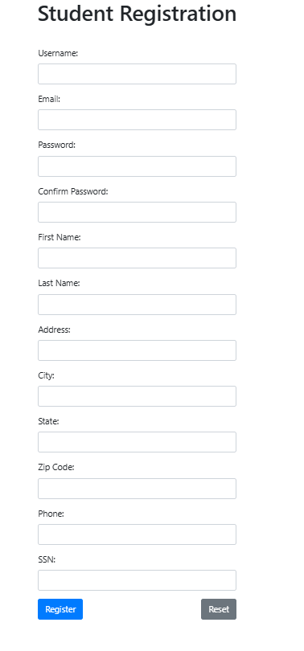

**Develop the registration page PHP source code.**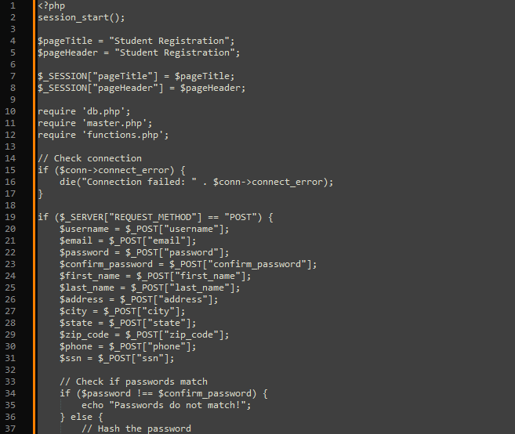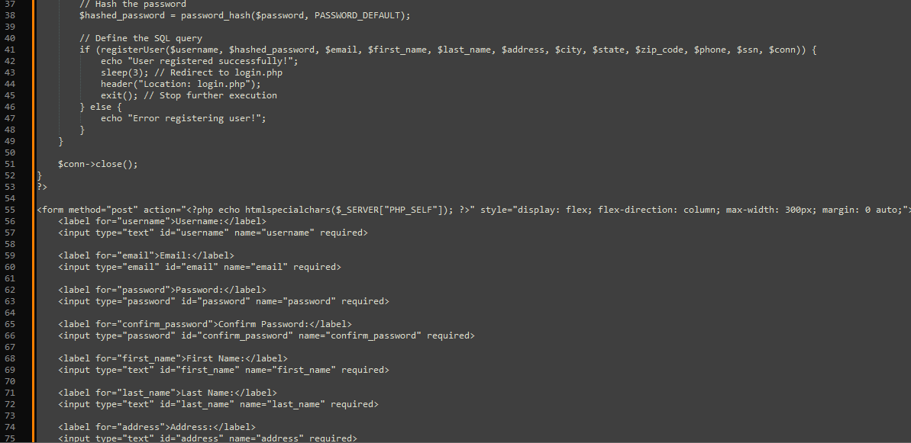

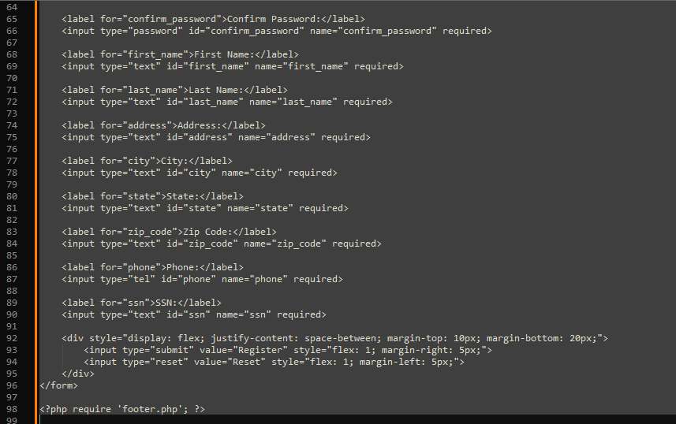

**Develop the table that saves the user information in the database.**

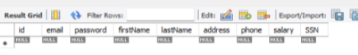

**Explain the steps taken to create the registration page and save the user information in the database.**

The first step involved creating a form on the registration page to send data to the insert.php page. The form includes labels and input fields for each required piece of information, along with a submit button. Upon clicking the submit button, the form data is sent to insert.php. The script connects to the database, assigns the submitted values to variables, and then inserts those values into the database.

**Provide screenshots of all developed pages, database, tables, layout, and source code.**



**login**

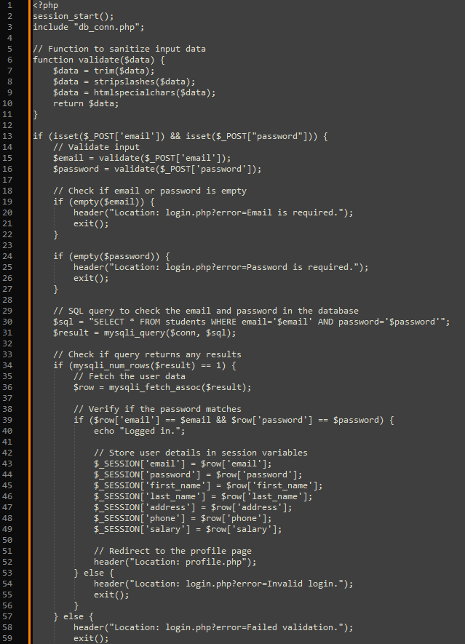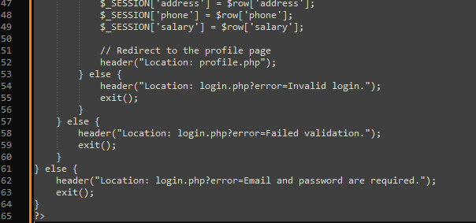

**Profile**

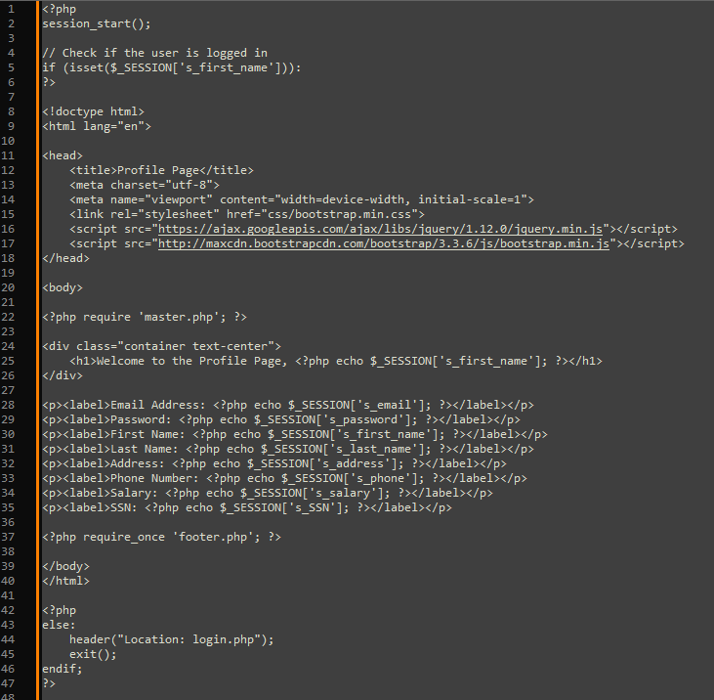

**Student Portal**

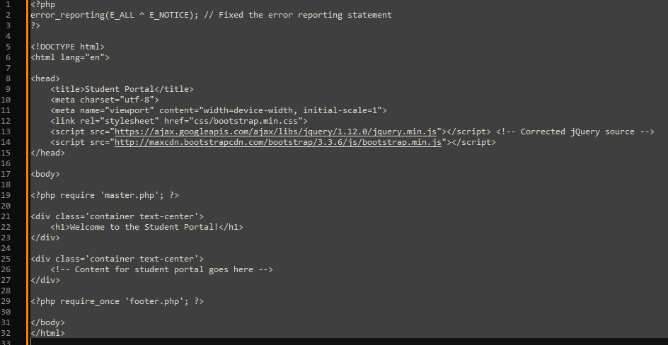

**Logout**

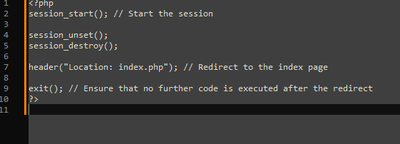

**Conclusion**

In conclusion, setting up PHP in XAMPP and developing a registration system was both challenging and a valuable learning experience. Although building the pages and saving user data in MySQL took time and caused some confusion along the way, the process was ultimately rewarding. By utilizing mysqli_connect() and creating a custom class for database connections, I gained a deeper understanding of working with databases. While it was a tough task, it was a great opportunity to grow and improve my skills as a developer.

**References**

GeeksforGeeks. (2024, June 5). *How to Insert Form Data into Database using PHP ?* GeeksforGeeks. https://www.geeksforgeeks.org/how-to-insert-form-data-into-database-using-php/

Hosting, S. W. (2021, August 17). *PhpMyAdmin Database Management Tutorial*. SiteGround. https://www.siteground.com/tutorials/phpmyadmin/database-management/

Tsui, F., Karam, O., & Bernal, B. (2018). Essentials of software engineering (4th ed.). Jones & Bartlett Learning.